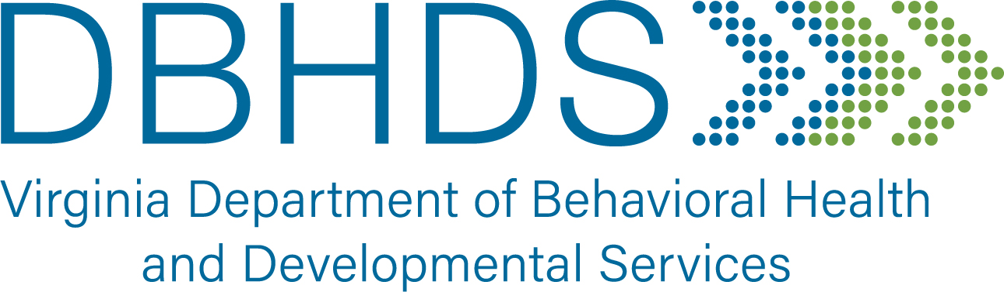
DBHDS ID/DD Guardianship Funding Request

CSB: Date:
CSB Contact:
Email Address:
Contact Number #:

Instructions: Please note that this is a request for reimbursement of funds paid in attorney fees by your agency. DBHDS does not issue the funds directly to the attorney.
- The individual for whom funding is requested must have been assigned an ID/DD-DBHDS Guardianship slot and approval from the Public Guardianship Program multidisciplinary panel.
- The request for funding should be the actual costs expensed in attorney fees but shall not exceed $2,000 per person.
- Funds are not guaranteed and are subject to denial if DBHDS allotted funding is expensed.
- The Funding Request Form and the Invoice from attorney should be submitted as two separate WORD documents via EMAIL to: public.guardianship@dbhds.virginia.gov

Individual’s Name | Funding Requested  (Not to exceed $2,000 per person) | Total
Click here to enter text. | Click here to enter text. | Click here to enter text.
Internal use only

Printed Name: Sheila Snead
Title: Community Integration Support Specialist
Signature: _________________________________________________

