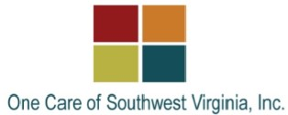
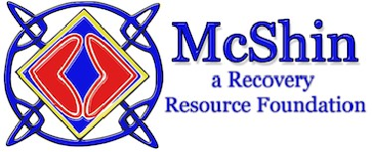

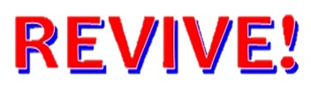
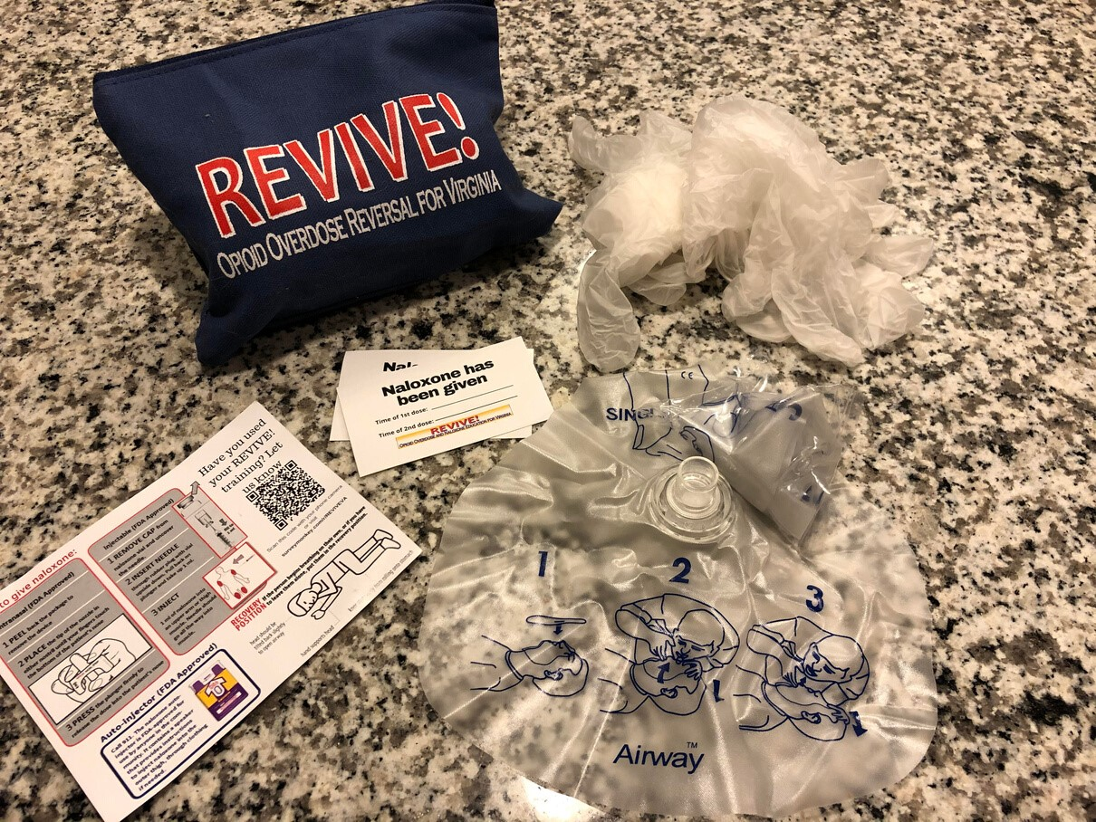

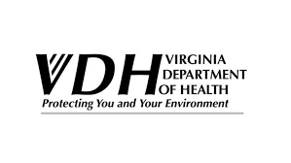
HOW TO RECOGNIZE AND
RESPOND TO AN OPIOID
OVERDOSE EMERGENCY
WITH NALOXONE
Naloxone only works if opioids
are in the body, it has no
effect on alcohol or other
drugs

It can take
minutes
1-3
to
start working and may require
more than one dose.

Effects can
last 30-90
minutes
, this varies per
person.

Naloxone may cause an
opioid dependent person to
go into
withdrawal
e.g.
(
nausea, vomiting, agitation,
muscle aches).
Naloxone is a medication
designed to temporarily
block
the effects of opioids
, and can
reverse overdose.

Naloxone Saves
Lives.
PO Box 1797
Richmond, VA 23218
ADDRESS
dbhds.virginia.gov search "revive"
Revised September 2021
WEB
WHAT IS
NALOXONE?
An opioid overdose can happen to
anyone taking opioids —
whether they are taking medications
prescribed or using them
recreationally. Opioids can cause a
person’s
breathing to slow down or
stop
— this is considered an overdose.
Latex-free gloves
Rescue breathing face mask
Instruction Card
A training completion card

And stickers to document time of
administration

To learn more about using naloxone
attend a REVIVE! training event!
These events are
free and
available to anyone
wanting to
learn how to save a life with
naloxone.
A REVIVE! Opioid Overdose
Response Kit is provided at each
training free of charge and
inlcudes:

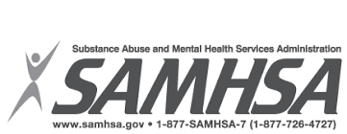
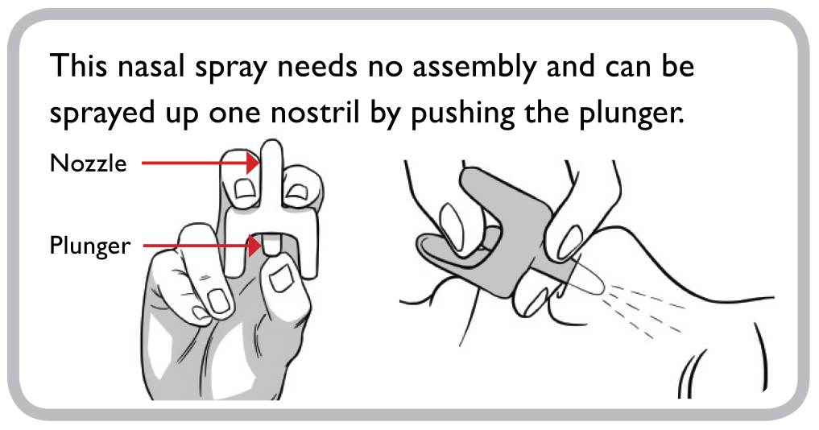
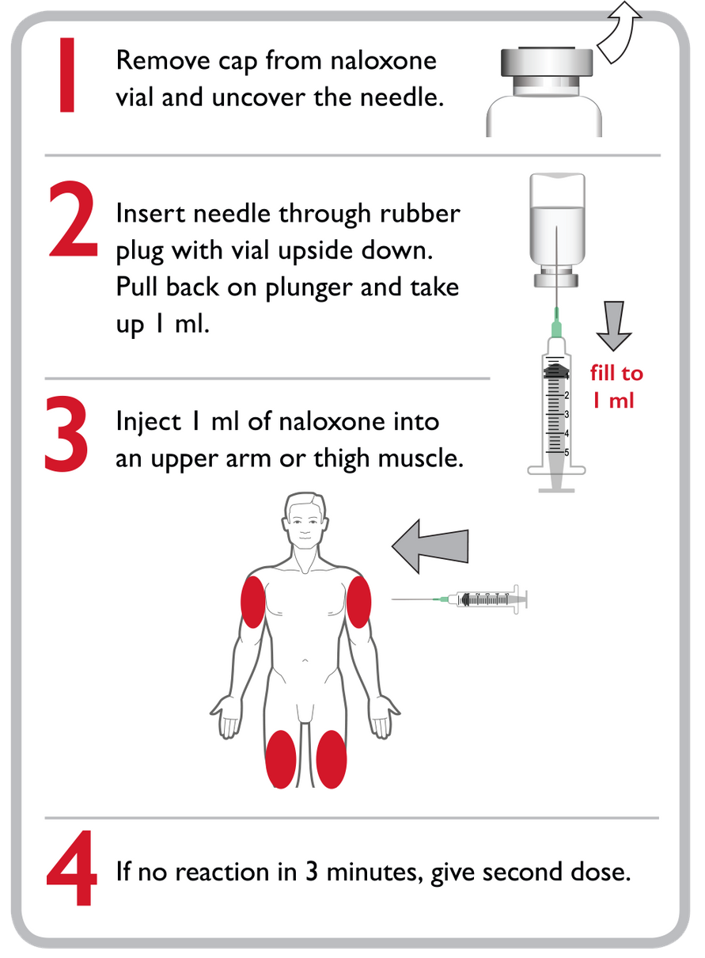
Hydrocodone
Oxycodone
Morphine
Codeine
Tramadol
Buprenorphine
Methadone

Opioids are a class of drugs that
includes prescription pain
medications like:
*and also street drugs like heroin and fentanyl

When a person consumes more
opioids than their body can
tolerate it can stop central
nervous system functions such as
breathing and heartbeat.

Mixing drugs
Lowered Tolerance (haven't
used opioids before or in a
while)
Using alone
Age and Physical Health
Mode of Transmission
Previous non-fatal overdose
Some of the primary risk factors
associated with overdose are:
RESPOND
Naloxone expires, visit
dbhds.virginia.gov to
learn where you can get
naloxone at no-cost.

REDUCE RISK
Use Naloxone if you suspect
someone is overdosing, even if
you are unsure.
OPIOIDS
OVERDOSE
Check for responsiveness
Call 911
Give 2 Rescue Breaths
Give Naloxone
Begin Rescue Breathing
If you suspect someone has
overdosed:
1
.
2
.
3
.
4
.
5
.

Unresponsive to yelling,
pinching, or a sternum rub
not breathing or having
really slow/shallow breaths
Having blue lips and/ or
fingertips
Someone may be overdosing
if they are

USING NALOXONE
Narcan Nasal Spray (FDA Approved)
IM Injection (FDA Approved)

Three ways to obtain Naloxone:
- Local Health Department* (no cost)
- Community Services Board (no cost)
- Local Pharmacy (Insurance/out-of-pocket
*not all health departments offer naloxone

